**Git and Github**

GIT- version control system(Distrubited)

Local

centralised

Distributed

Difference between GIT and Github

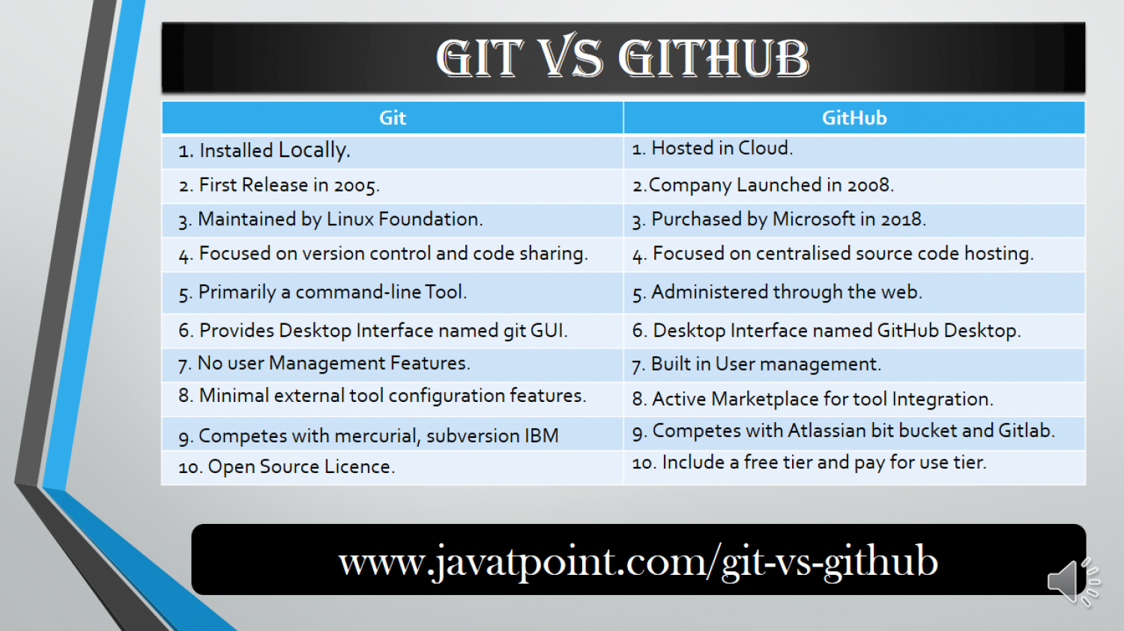

Github - platform where the version control system is used.

Git repository - folder managing of the git

Commad for making a folder git repository - git init

Three phases of Git Phases

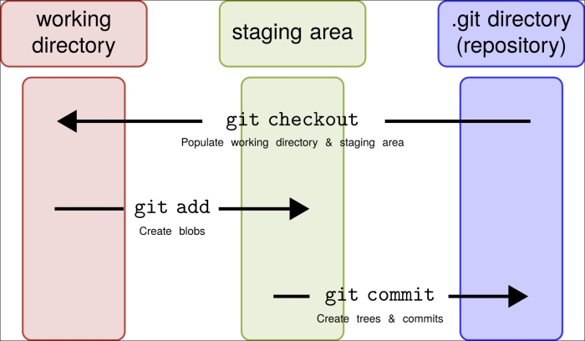

***For renaming the file (git mv file name updated name) - GIT***

The git log command displays all of the commits in a repository's history. By default, the command displays each commit's: Secure Hash Algorithm (SHA) author.

Gitignore for ignoring the log file which have a sensitive

Task - now you need to ignore all file which have name extension of .doc

2- do not ignore the file abc.doc?

3 in the git repository make an empty folder and ignore the empty folder

Branching in git

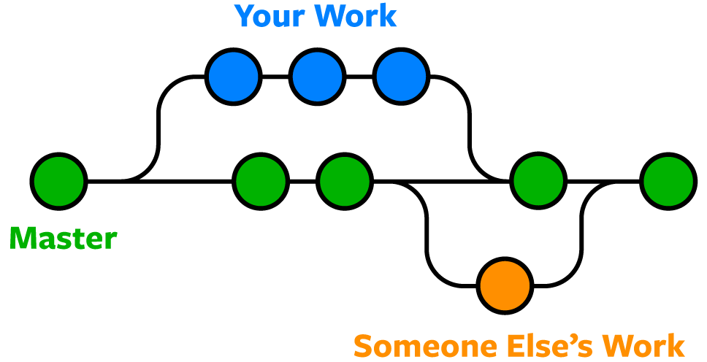

For change the branch git checkout where you have to go

Git merge- merging file from one branch to another branch

Fork - make a copy of the file in your github account from other git……

